**Total Hands** (VsHero)

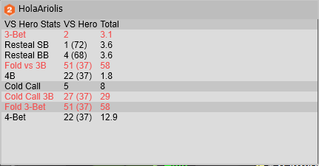

**BB Fold to BTN Steal** (BBvsST) **BB Fold vs SB Steal** (BBvsST)

